Presidency University

IPR – 165

Manaswini R

**Design and develop a tactile book with images and an audio output to represent the images when the user touches it**

# Introduction:

# **Background Overview:**

# **Tactile books have long been instrumental in providing access to literature and education for individuals with visual impairments. By incorporating raised tactile elements, these books enable readers to engage with content through touch, fostering literacy and independence.**

# **Need for Innovation:**

# **Despite the benefits of tactile books, traditional formats often lack dynamic content representation. Incorporating images alongside tactile elements enhances the reading experience, but there remains a gap in providing contextual audio feedback corresponding to these images.**

# **Proposed Solution:**

# **The project aims to bridge this gap by designing and developing a tactile book that not only includes images but also provides audio output corresponding to the content of these images. This innovative approach leverages a camera module to scan QR codes embedded within the tactile book, triggering audio responses tailored to the scanned image.**

# **Objectives:**

# **Enhance accessibility for visually impaired individuals by providing multi-sensory engagement through tactile, visual, and auditory channels.**

# **Facilitate independent exploration and comprehension of visual content within tactile books.**

# **Introduce a novel integration of technology to augment traditional tactile book formats, thereby improving inclusivity and educational outcomes.**

# **Scope of the Report:**

# **Overview of current tactile book technologies and their limitations.**

# **Design and development process for integrating tactile elements, images, and audio output.**

# **System architecture, hardware components, and software implementation details.**

# **Evaluation of the developed solution's effectiveness and usability.**

# **Recommendations for future research and applications in the field of accessible technology.**

# **Target Audience:**

# **Educators, researchers, and developers interested in inclusive design and assistive technology.**

# **Organizations and institutions involved in accessibility initiatives for individuals with visual impairments.**

# **Individuals with visual impairments and their caregivers seeking innovative tools for learning and leisure.**

# **Structure of the Report:**

# **The report is organized into sections covering background research, design objectives, system architecture, hardware and software development, integration and testing, evaluation, conclusion, and future directions.**

# **Each section provides detailed insights into the project's methodology, findings, and implications for accessible technology innovation.**

Applications:

**Educational Tool for Visually Impaired Individuals:**

* The tactile book can serve as an educational tool for individuals with visual impairments, providing them with access to visual content through tactile representations and audio descriptions.
* It can help them learn about various subjects such as history, geography, and science.

**Interactive Storytelling for Children:**

* Children can explore interactive stories through the tactile book, with each page featuring tactile illustrations and accompanying audio narration.
* This enhances their storytelling experience and encourages engagement with the content.

**Language Learning Aid:**

* The tactile book can aid in language learning by featuring tactile representations of vocabulary words along with audio pronunciation.
* Users can touch the images to hear the corresponding words pronounced, facilitating language acquisition.

**Accessible Art Gallery Guide:**

* In art galleries or museums, the tactile book can provide an accessible guide for visitors, offering tactile representations of artworks along with audio descriptions.
* This allows individuals with visual impairments to experience and appreciate the art on display.

**Assistive Technology for Special Needs Education:**

* The tactile book can be used as assistive technology in special needs education settings, providing students with sensory processing disorders or learning disabilities with a multisensory learning experience.
* It can help them engage with educational content in a way that suits their needs.

**Interactive Exhibit for Science Museums:**

* In science museums or exhibitions, the tactile book can serve as an interactive exhibit, allowing visitors to explore scientific concepts through tactile models and audio explanations.
* This enhances accessibility and engagement for visitors of all abilities.

**Travel Guide for Tourists:**

* As a travel guide, the tactile book can feature tactile maps, landmarks, and cultural highlights of a destination, accompanied by audio descriptions and travel tips.
* This provides an inclusive travel experience for tourists with visual impairments.

**Personalized Learning Tool for Individuals with Autism:**

* The tactile book can be customized to cater to the sensory preferences of individuals with autism, offering tactile stimuli and audio feedback tailored to their needs.
* It can support their learning and sensory integration in educational settings.

Background Research

Overview of Tactile Books:

* Tactile books have served as invaluable tools for individuals with visual impairments, offering a tactile representation of printed text and illustrations.
* These books have raised textures that allow readers to feel and understand the information on their own.

Limitations of Traditional Formats:

* While tactile books facilitate access to written content, they often lack dynamic representation of images, limiting the richness of the reading experience.
* Existing solutions for incorporating images into tactile books may not provide contextual information or supplementary content to enhance comprehension.

Emerging Trends in Accessibility Technology:

* Recent advancements in technology have opened up new possibilities for enhancing the accessibility of educational materials for individuals with visual impairments.
* Innovations such as image recognition, audio feedback systems, and interactive interfaces offer promising avenues for improving the inclusivity and effectiveness of tactile learning resources.

Need for Multisensory Integration:

* Research suggests that multisensory learning approaches, which engage multiple senses simultaneously, can significantly enhance learning outcomes for individuals with visual impairments.
* Integrating tactile, visual, and auditory modalities in educational materials has been shown to promote deeper understanding, retention, and engagement.

Existing Solutions and Their Limitations:

* While some tactile books incorporate basic audio features, such as sound effects or narrated text, few provide contextual audio feedback corresponding to specific images.
* Challenges in accurately interpreting and representing visual content in tactile form remain, often resulting in limited accessibility and comprehension for users.

Relevant Resources:

* "Tactile Picture Books Project" by the University of Colorado Boulder provides insights into the design and development of tactile books for children with visual impairments.
* "Accessible Books Consortium" by the World Intellectual Property Organization offers resources and guidelines for producing accessible books for individuals with print disabilities.

Design Objectives and Requirements

Enhancing Accessibility:

* The primary objective of the project is to enhance accessibility for individuals with visual impairments by providing a multi-sensory learning experience.
* By integrating tactile, visual, and auditory elements, the design aims to cater to diverse learning styles and abilities, promoting inclusivity and equal access to educational materials.

Facilitating Independent Exploration:

* Empowering users to independently explore and comprehend visual content is a key goal of the design.
* The tactile book with integrated audio output enables users to access contextual information about images without relying on external assistance, fostering autonomy and self-reliance.

Innovative Integration of Technology:

* The project seeks to pioneer a novel integration of technology with traditional tactile book formats, leveraging advancements in image recognition and audio feedback systems.
* By incorporating a camera module and QR code scanning functionality, the design introduces an interactive and dynamic dimension to tactile learning resources.

Usability and User Experience:

* Ensuring the design is intuitive, user-friendly, and engaging is essential for its effectiveness and adoption.
* User feedback and iterative design refinements are integral to optimizing the usability and user experience of the tactile book and its accompanying audio output system.

Durability and Accessibility:

* The tactile book must be durable and resistant to wear and tear, ensuring longevity and accessibility for repeated use.
* Considerations for the size, weight, and ergonomics of the book aim to make it easy to handle and manipulate for individuals with visual impairments.

Compatibility and Scalability:

* The design should be compatible with existing assistive technologies and scalable for future enhancements or adaptations.
* Modular components and open-source software frameworks facilitate interoperability and encourage collaboration within the accessibility technology community.

Ethical Considerations:

* Upholding principles of accessibility, privacy, and inclusivity is paramount throughout the design and development process.
* Ensuring the dignity, autonomy, and well-being of users with visual impairments guides decision-making and implementation of the project.

Resource Allocation and Budget:

* Efficient resource allocation, including time, budget, and personnel, is essential for the successful execution of the project.
* Leveraging open-source resources, collaborative partnerships, and community engagement can help maximize the impact and reach of the design.

Component Selection:

Hardware components are chosen based on functionality, compatibility, and reliability. Factors like size, weight, power consumption, and cost are considered to ensure optimal selection.

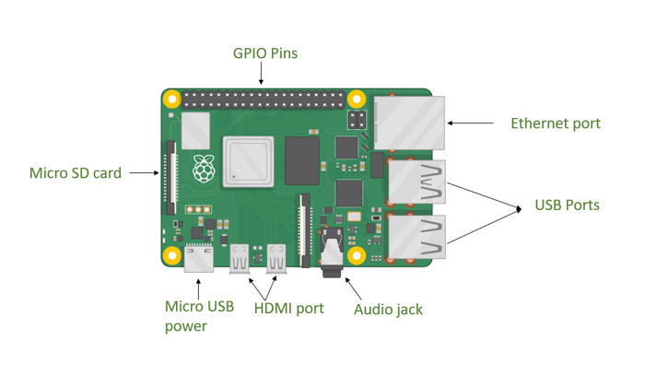

Camera Module:

* A camera module with high resolution, sensitivity, and compatibility with the microcontroller is selected. Features such as auto-focus and low-light performance are prioritized for clear image capture.



Audio Output System:

* Speakers or headphones with clear sound quality and adequate volume range are chosen. Considerations are made for impedance and form factor to ensure compatibility and user satisfaction.

Power Supply:

* A reliable power supply, considering battery type, capacity, and voltage regulation, is essential for uninterrupted operation, particularly for portable use.
* The recommended power as per raspberry pi documentation is 5V/3A adapter.
* For certain models like the Raspberry Pi Zero W/2W, you can power the device using a laptop. As for the Raspberry Pi 4 Model B, if you're not using the USB ports, you might also be able to power it using a laptop, as it consumes more power.

Physical Design:

* Hardware components are designed with user comfort, ergonomics, and durability in mind. Materials, form factor, and layout are optimized for intuitive interaction and longevity.

Integration and Assembly:

* Components are assembled meticulously with attention to cable management and enclosure design. Thorough testing is conducted to verify functionality and reliability.

Documentation and Compliance:

* Comprehensive documentation, including schematics, datasheets, and assembly instructions, is provided for replication and troubleshooting. Compliance with relevant standards ensures safety and interoperability.

Software Development:

QR Code Processing:

* Develop software algorithms to process QR codes captured by the camera module. Utilize image recognition techniques to decode QR codes and extract relevant information, such as image identifiers or metadata.

Audio Output Generation:

* Implement software functionality to generate audio output corresponding to scanned images. Retrieve audio files associated with each image from a database or memory storage upon scanning a QR code.

Code Snippet:

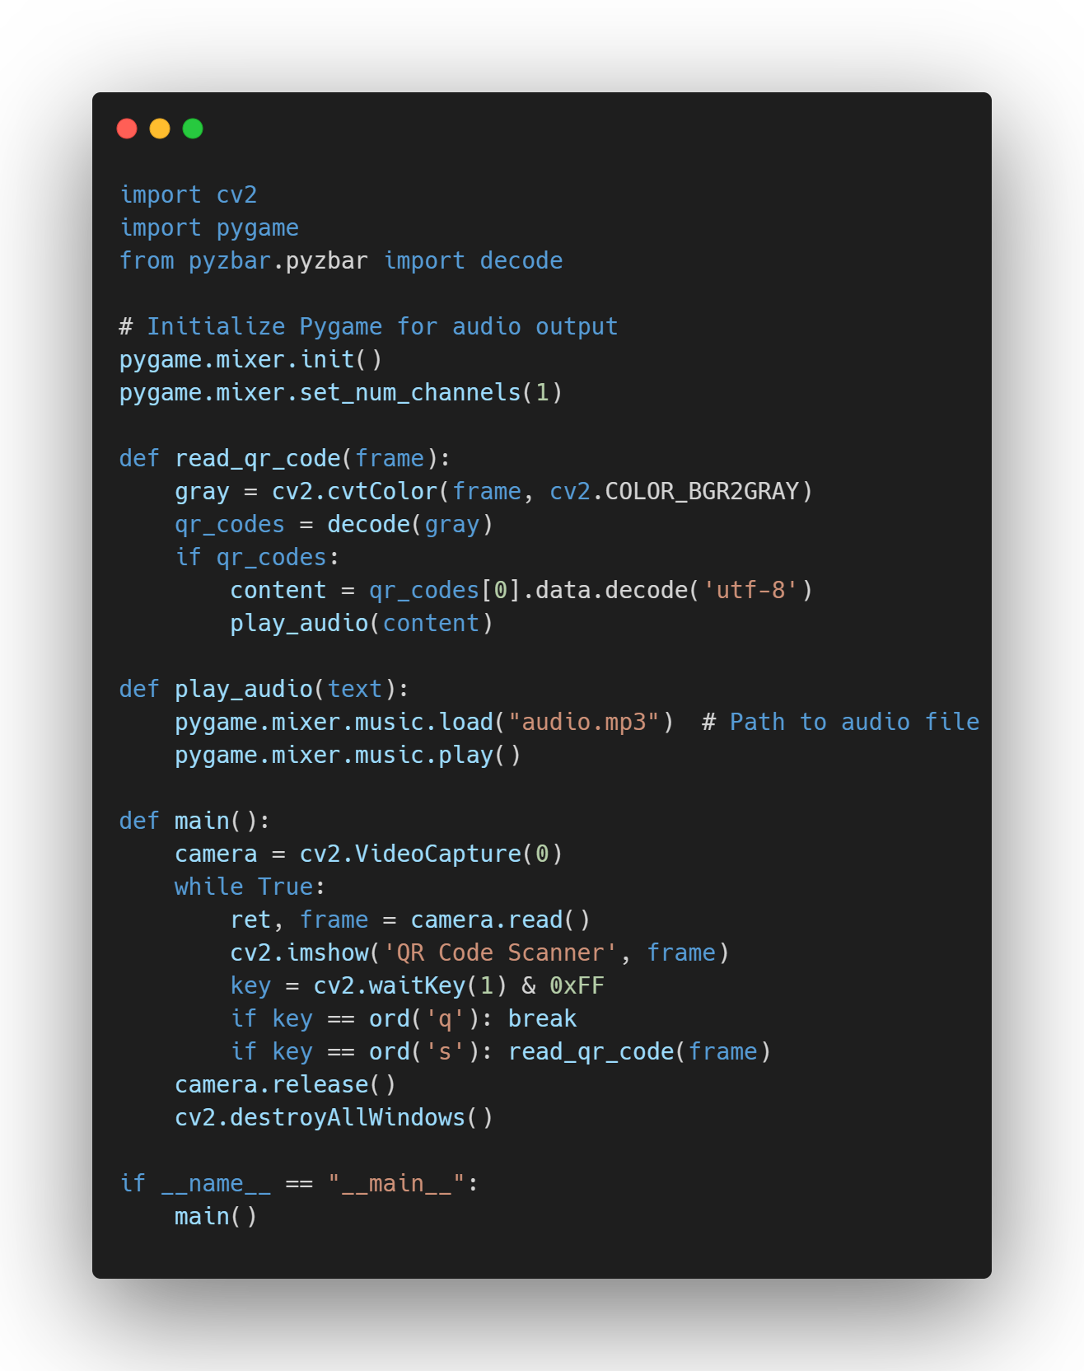

Testing and Debugging:

* Conduct rigorous testing procedures to verify the functionality and performance of the software components. Identify and address any bugs or issues through systematic debugging processes.

Optimization for Performance:

* Apply software optimization techniques to improve the performance and efficiency of the prototype system. Optimize algorithms and minimize resource usage for enhanced functionality.

Compatibility and Interoperability:

* Design the software to be compatible with different hardware configurations and operating environments. Ensure interoperability with external devices for seamless integration within the prototype system.

Relevant Resources:

Raspberry Pi Official Website:

* Raspberry Pi - <https://www.raspberrypi.org/>

Adafruit Learning System:

* Adafruit Learning System - <https://learn.adafruit.com/>

Instructible Guide - Raspberry Pi Audio Output:

* Raspberry Pi Audio Output Guide - <https://www.instructables.com/id/Raspberry-Pi-Audio-Output/>

Raspberry Pi Camera Module Documentation:

* Raspberry Pi Camera Module Documentation - <https://www.raspberrypi.org/documentation/hardware/camera/>

Adafruit Tutorial - Raspberry Pi QR Code Reader:

* Raspberry Pi QR Code Reader Tutorial - <https://learn.adafruit.com/adafruit-qr-code>